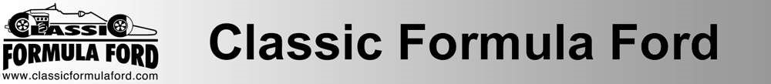

CLASSIC FORMULA FORD CLUB : 2023 APPLICATION FORM
I hereby apply for membership of the Classic Formula Ford Club for the 2023 season and enclose the appropriate fee. Please make cheques payable to the Classic Formula Ford Club. (Delete as appropriate).
- Associate Membership : Annual Fee £10. This entitles you to attend all social events organised by the CFFR during the year, and puts you on the mailing list for any newsletters, emails etc.
- Racing Membership : Annual Fee £50. If you intend to race in the Classic Formula Ford 1600 Championship in 2023. Racing Membership is a mandatory requirement for all drivers.

PERSONAL DETAILS : (IN BLOCK CAPITALS PLEASE)
Surname ……………………………………………………………………………………………………..

Forenames ……………………………………………………………………………………………....……..
Address ……………………………………………………………………………………………………..
……………………………………………………………………………………………………..

Postcode ……………………………………………………………………….…………………………. Home Telephone ……………………………………………………………………………………………………..

Business Telephone ……………………………………………………………………………………………………..

Mobile Telephone ……………………………………………………………………………………………………..
Email Address ………………………………………………………………………………………………….……………
FOR RACING MEMBERS ONLY:
Competition Licence No. …………………………………………………………………………….………………
HSCC Membership No. ……………………………………………………………………………………………………...
Car Manufacturer ……………………………………………………………………………………………………...
Model / Year/ Engine Tuner ……………… / …………… / …………………………………………………………..
PLEASE NOTE: Competition numbers will be confirmed by Andy Dee Crowne, the HSCC coordinator for the championship.

I hereby agree to be bound by the provisions of the regulations relating to the Classic Formula Ford Club and its Championship.

I have read, understood, and agree to abide by the driving standards as set out in the Classic FF1600 Driving Standards Guide. This Guide is provided to all prospective members and is also available to download from www.classicformulaford.com

Signed / Dated ……………………………………… / ………..…………………………………………………
1
Payment Details

Please make Cheques* made payable to: The Classic Formula Ford Club.

Cheques should be posted with a completed copy of this membership form to:

Marion Saunders
Redstack
3, The Square
Braughing
Ware
Hertfordshire
SG11 2QS

Please note that from Summer 2021 the Bank Account Details have changed as shown below

Direct Bank Transfers* can be made to the account Classic Formula Ford Club - details below:

Account Name: Classic Formula Ford Club
Bank Name: Metrobank
Acc No: 42083399
Sort Code: 23-05-80
Please use the Reference CFFR2023 and include your surname also.

(*circle payment method as appropriate)

